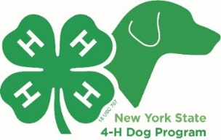 | The NYS 4-H Dog Program  is holding a Trick Dog Contest! | 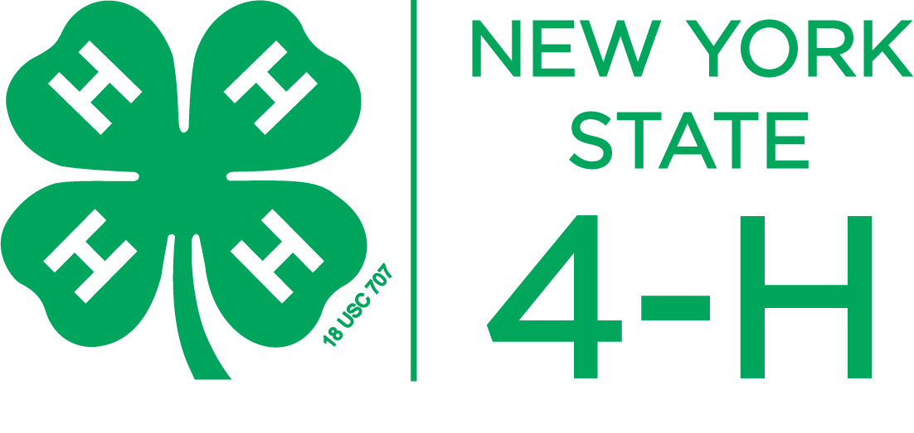

In an effort to keep our 4-H dog handlers challenged as we enter months of cold & snow, we would like to offer a Winter Trick Dog Class similar to the American Kennel Club (AKC) program now in place. https://www.akc.org/sports/trick-dog/

Starting on January 1st, 2021, the 4-H Dog Program will be offering Trick Dog Certificates to all qualifying dog/handler teams. All tricks will be at the AKC Novice Trick Dog Level.

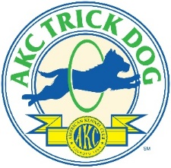
If you have already received an AKC Trick Dog Novice Title you can apply for the 4-H certificate in that class & move up to the next class simply by submitting a copy of the AKC Certificate.

We will award certificates in January, February & March, and you can “move up” the next month to the next level once you have completed a class. You can also submit your video to an AKC evaluator to earn an AKC Trick Dog title. The AKC Trick Dog Levels are Novice, Intermediate and Advanced.

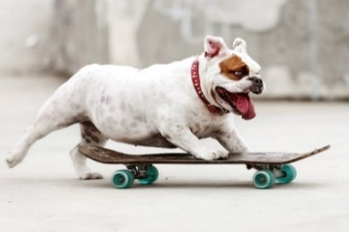
Here’s How It Works:
- For the Novice level, teach your dog 10 of the AKC qualifying tricks listed below. If your dog already has an AKC CGC title (submit copy) you only need to complete 5 additional tricks for a total of 15 for the AKC Intermediate level or 20 for the Advanced level.
- Have a county dog leader* witness your tricks in person & sign a marked “tricks” checklist (below). *A county dog leader can be from any NYS county.
- Have a county dog leader* witness your tricks by video & submit a marked & signed
checklist to: Rev. Liz Meacham, 22 Keeney Street, Warsaw, NY 14569

4-H Age Groups (as of January 1st, 2021): Junior: Ages 8-12 Senior: Ages 13-19

Qualifying tricks:

____ Balance beam (walk on board a few inches off floor
____ Bark on cue (speak)
____ Crawl (dog on belly, crawls at least 3 body lengths)
____ Fetch it (ball etc. 10 ft. away, bring to within 2 ft of handler)
____ Find it (find treat under a cup or similar object)
____ Get your ________, (leash, brush, name of toy)
____ Get in (gets in box)
____ Sits in box (on cue)
____ Get on (gets on step or low platform – 4 paws on)
____ Hand Signal (choose one: down, sit or come)
____ High Five
____ Hold (hold an object for 3 seconds)
____ Jump (through hoop over low bar)
____ Kennel Up (go in crate & stay until released)
____ Kiss (point to cheek or back of hand)
____ Paws up (2 front paws on stool or step)
____ Shake Hands
____ Spin in Circle
____ Touch it (hand or target object)
____ Tunnel (agility tunnel or child’s tunnel)
____ Other (handler’s choice)

All Handler/Dog teams that complete a class or classes will receive a certificate & rosette from 4-H.

For more information, contact Liz Meacham at liz.meacham@yahoo.com.

To register, submit your video, completed checklist, and copies of your AKC Certificates, visit: https://cornell.ca1.qualtrics.com/jfe/form/SV_czM3wbSLecc5cvH

